Ohio “Income Tax Savings Incentive”

Using same design as South Carolina:

When user selects “compare” on polygon in state of “Ohio”, the last line (field) in the pop up should be “Income Tax Credits”, with value = “$25,000” or their last saved value (as described in South Carolina Website Algo spec sheet). For instance, if a user is logged, we auto compute the value they have previously entered and display it. Value is a href link to the prompts below (Same method as South Carolina, save all variables as we go, apply to account if account email/password is created at end).

Mouseover “Ohio Income Tax Credit” should say the following: “The Tax savings is a valuable financial incentive that rewards those to pay Ohio State income taxes and invest into Ohio Opportunity Zone Communities.”

The value should be “$25,000” with a mouseover stating: “Personalize your tax credit”.

In addition: at top of pop up next to state, we have the following text for an href: “$[X] left for State Income Tax Credits.”) *Mouseover: “First come, first serve. Updated in real time. Click here to put your name on the waitlist for additional savings”.* Variable X is set to a static number, “$35,000,000”.

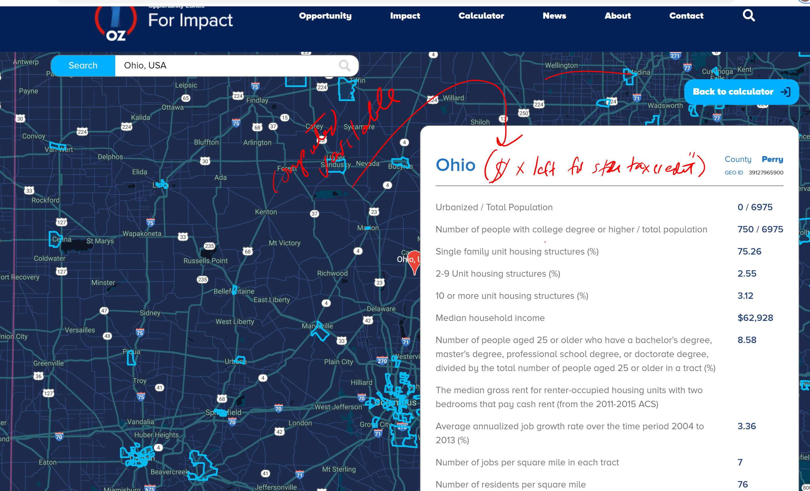

Pseudo Code (same design as South Carolina):

Prompt Y/N: Do you pay Ohio State incomes taxes?

If(prompt_value = yes) then

Prompt (Y/N): Do you plan on making an investment (business or real estate) into an Ohio Opportunity Zone?

If(promptvalue = y) then

Prompt(Numeric Text Box: “Please enter your investment amount”)

Ohio Tax Saving Incentive Tax Credit Value = min(1,000,000,“investment_amount* 10%)

Else(“You need to make an investment into an Ohio Opportunity Zone which invests exclusively in Ohio to receive this tax savings”).

Else(“You need to pay Ohio income taxes to receive the savings offered”).